AWS CloudWatch

**Introduction**

AWS CloudWatch is a monitoring and observability service provided by Amazon Web Services (AWS). It allows you to collect, monitor, and analyze log files and metrics generated by your AWS infrastructure and applications in real-time.

**Key Features**

1. **Metrics Monitoring**: Collect and track metrics for AWS resources and applications.
2. **Logs Monitoring**: Centralized logging and analysis for applications and services.
3. **Alarms and Notifications**: Set alarms on metrics to trigger actions or notifications.
4. **Dashboards**: Create customizable dashboards to visualize metrics and logs.
5. **Integration**: Seamless integration with other AWS services for comprehensive monitoring.
6. **APIs and CLI**: Manage CloudWatch resources programmatically using APIs and command-line interface (CLI).

**Components**

**1. Metrics**

* **Definition**: Metrics are data points related to the performance of your AWS resources or applications.
* **Types**: Standard (AWS services) and custom (your own metrics).
* **Use Cases**: Monitor CPU usage, storage, request counts, etc.

**2. Logs**

* **Definition**: Log data generated by applications, operating systems, and AWS services.
* **Sources**: EC2 instances, Lambda functions, CloudTrail logs, etc.
* **Use Cases**: Troubleshooting, security analysis, compliance auditing.

**3. Alarms**

* **Definition**: Automated actions triggered based on predefined thresholds.
* **Actions**: Send notifications, trigger Auto Scaling, etc.
* **Use Cases**: Notify when CPU usage exceeds 80%, scale EC2 instances based on demand.

**4. Dashboards**

* **Definition**: Customizable visualizations of metrics and logs.
* **Components**: Graphs, text widgets, logs viewer.
* **Use Cases**: Create a single view for monitoring application performance.

**5. Events**

* **Definition**: Stream of system events that describe changes in AWS resources.
* **Use Cases**: Automate response to operational changes, integrate with other AWS services.

**Getting Started**

**Step 1: Create AWS Account**

* Sign up for an AWS account if you haven’t already.

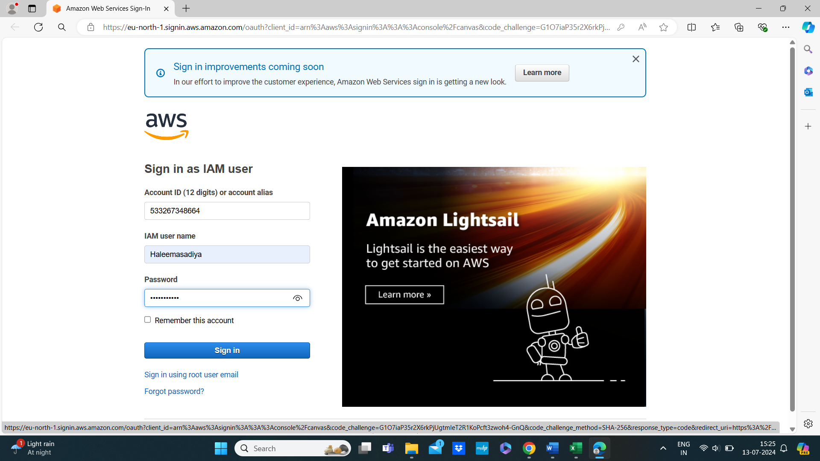

**Step 2: Access CloudWatch**

* Go to AWS Management Console.
* Navigate to CloudWatch under Services.

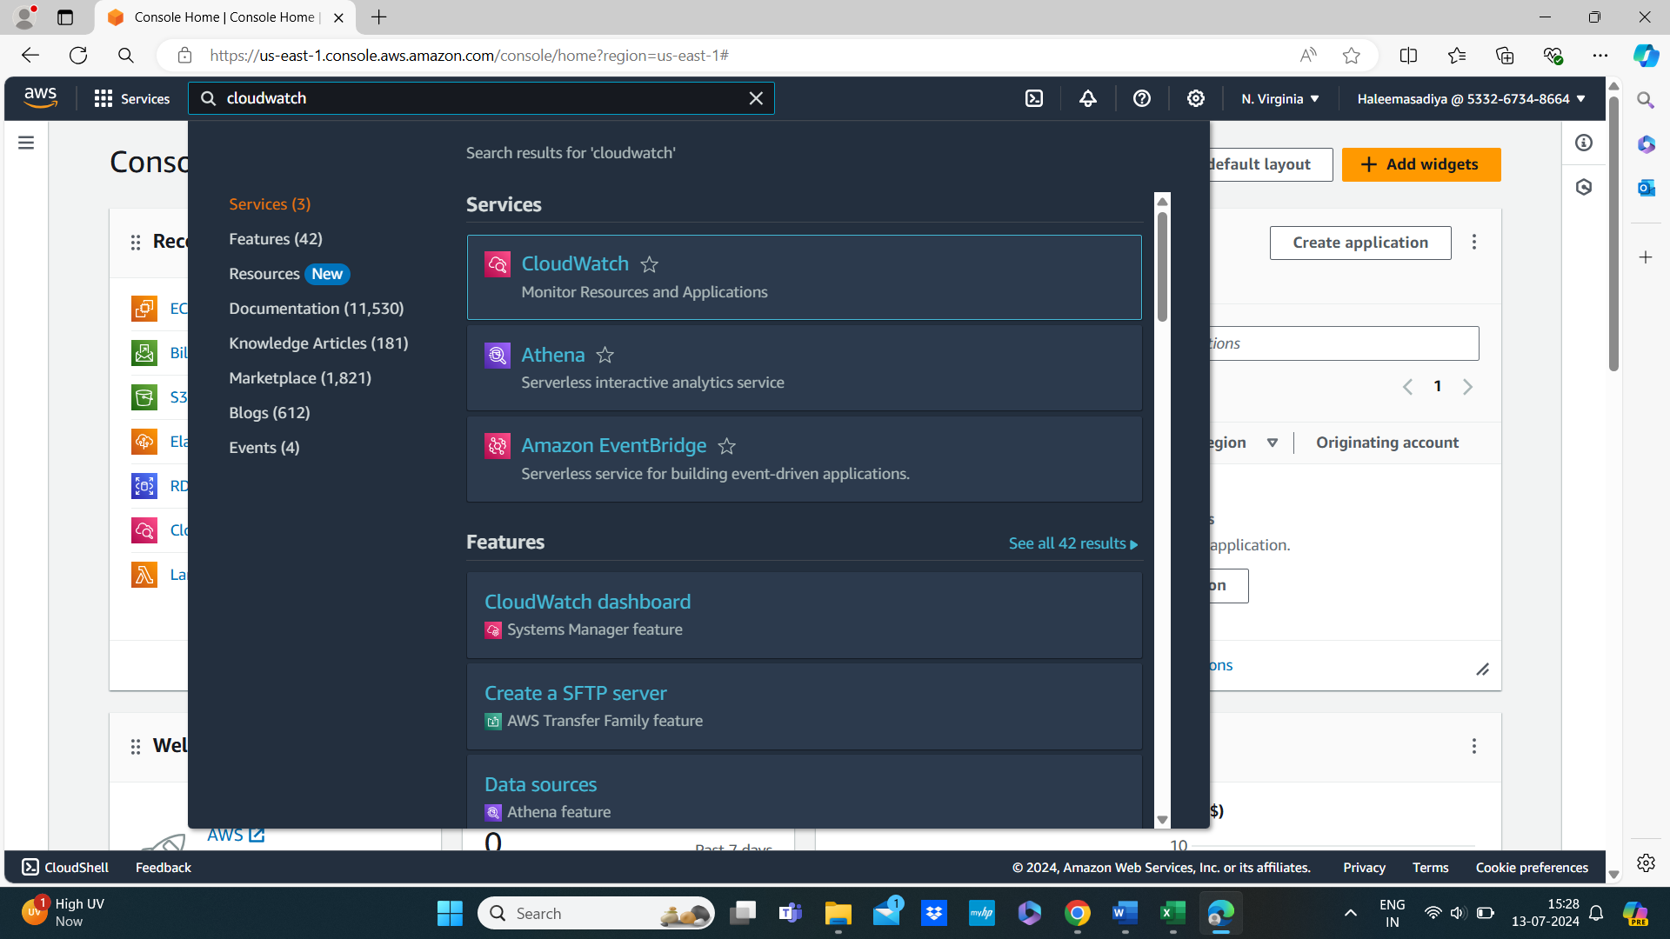

**Step 3: Explore Dashboard**

* Check default metrics and logs.
* Create custom dashboards.

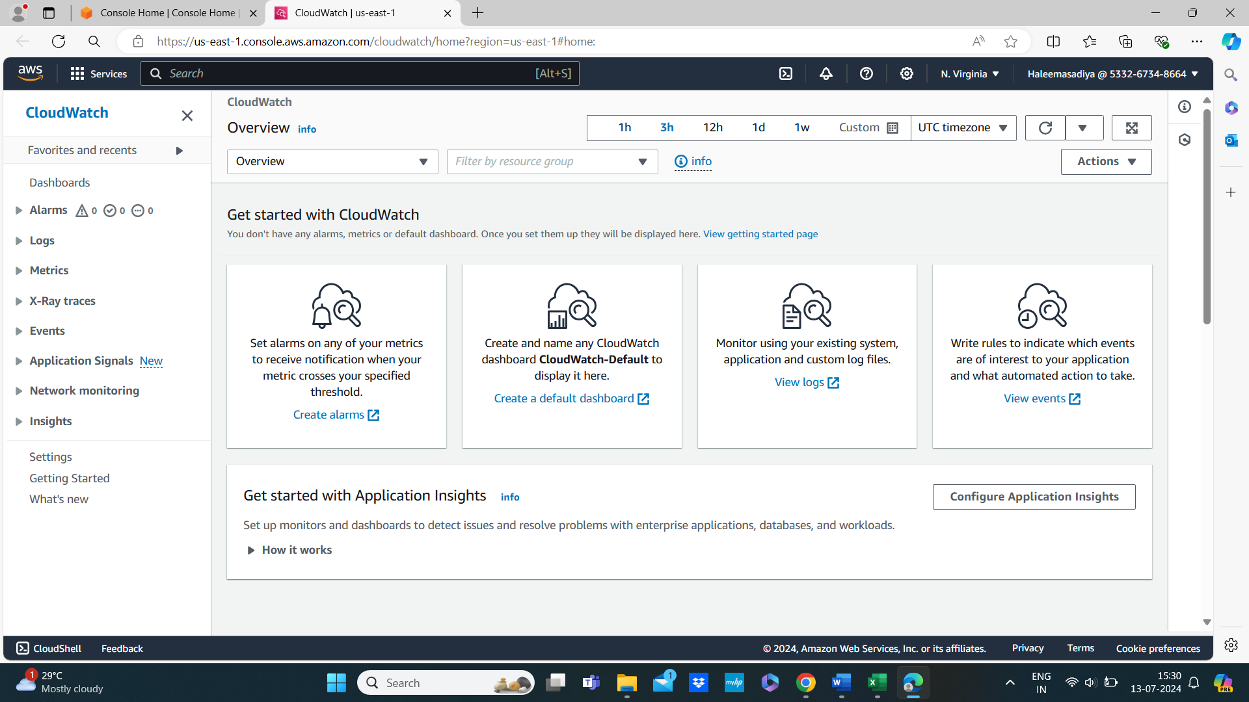

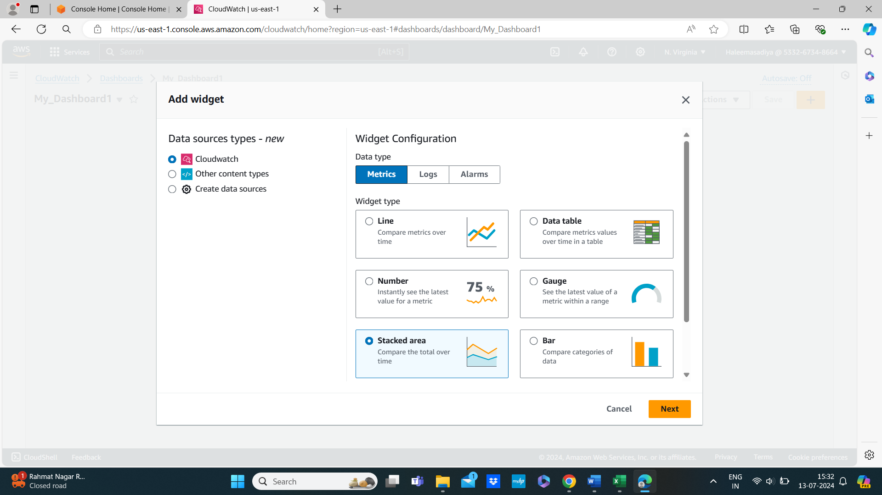

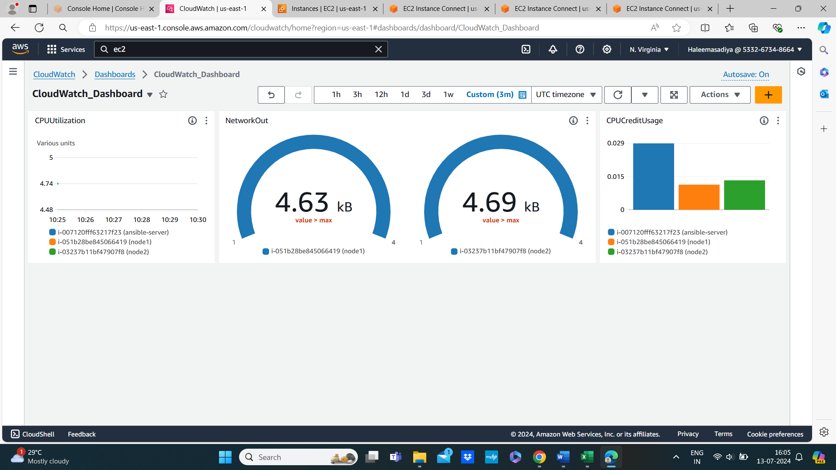

**Step 4: Set Up Alarms**

* Define metrics thresholds.
* Configure actions (e.g., SNS notifications).

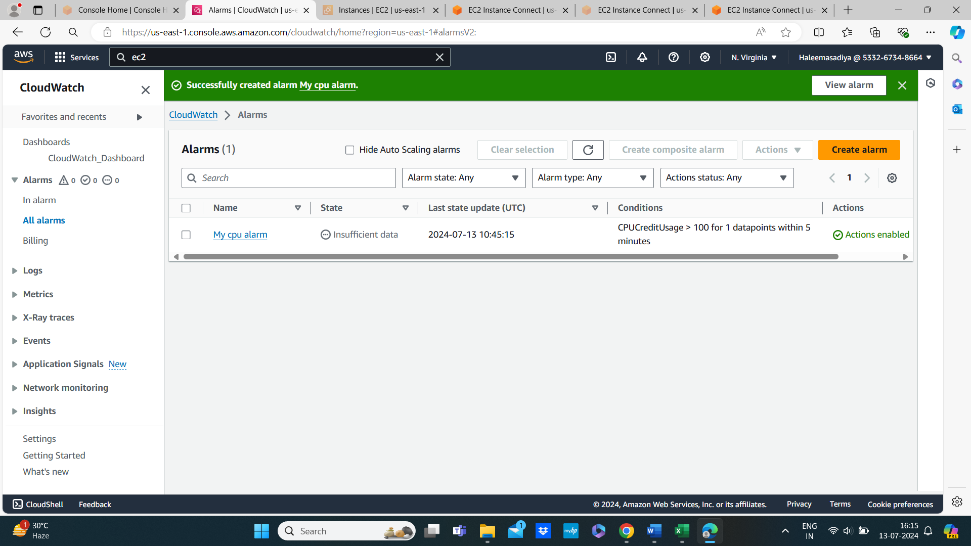

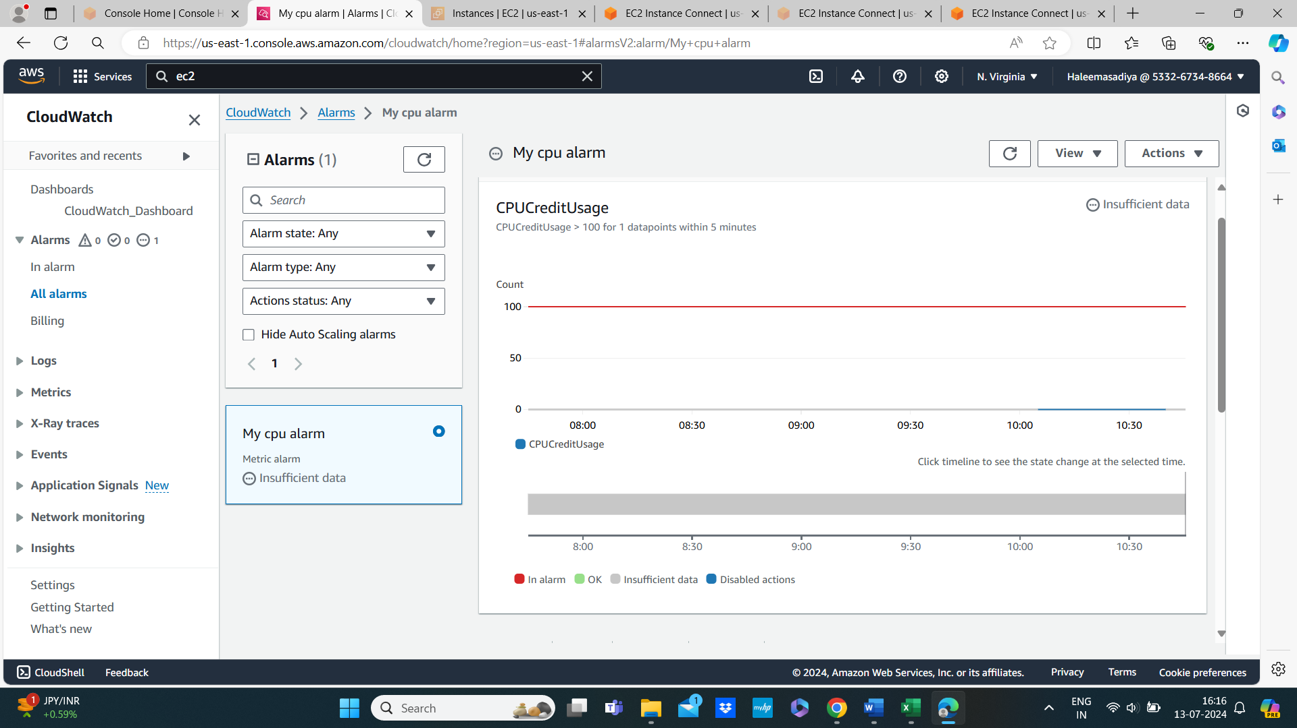

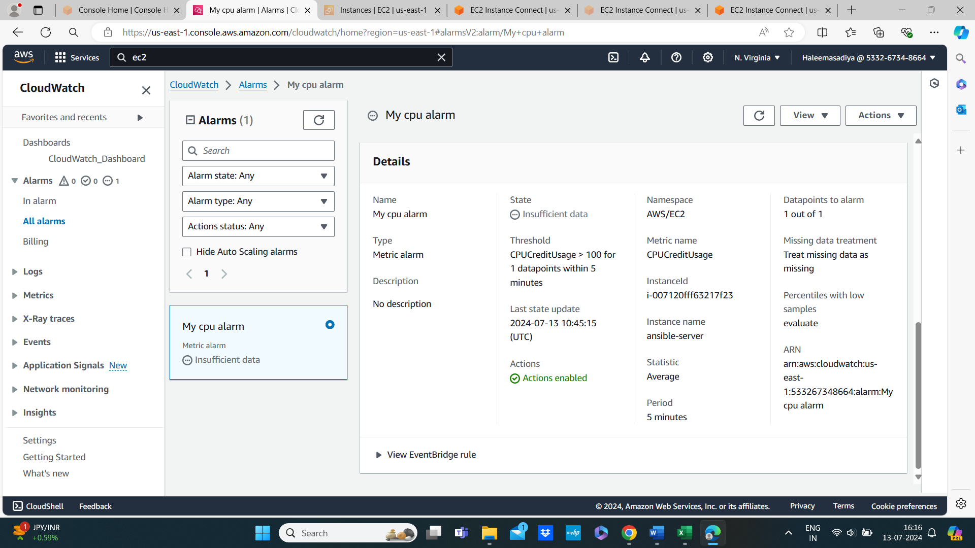

**Step 5: Explore Logs**

* View log groups and streams.
* Create metric filters and alarms from logs.

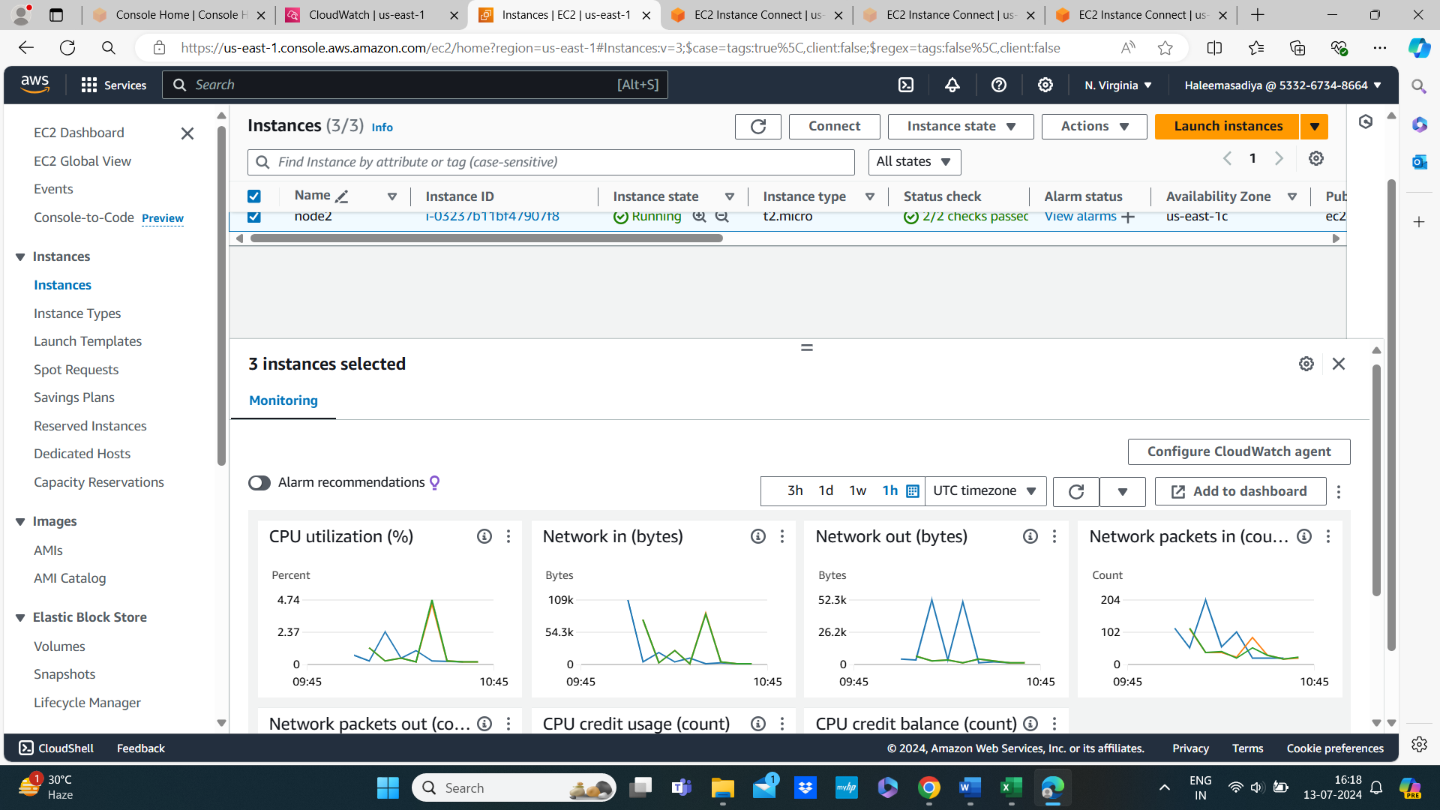

**Pricing**

* Pay-as-you-go pricing based on usage of metrics, logs, alarms, etc.
* Free tier available for new AWS accounts.

**Resources**

* [AWS CloudWatch Documentation](https://docs.aws.amazon.com/cloudwatch/)
* [AWS CloudWatch Pricing](https://aws.amazon.com/cloudwatch/pricing/)

**Conclusion**

AWS CloudWatch provides essential tools for monitoring, troubleshooting, and optimizing your AWS environment. By leveraging its capabilities, you can ensure the reliability and performance of your applications and infrastructure.